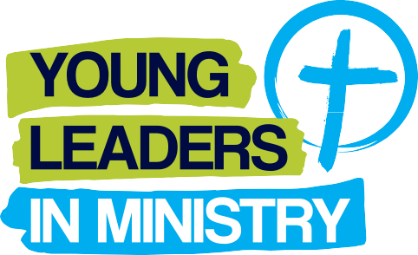

Church of Ireland young people aged from 15-25 years who can demonstrate a current involvement in the Church
of Ireland.

Training and development courses, mission teams, leadership opportunities and placements that can
be shown to:
Significantly develop the faith of the young adult applicant.
Grow the skills of the applicant especially, but not
confined to, leadership skills.
Be of significant use to the ministry of the Church of Ireland in the 12 months following the completion
of the opportunity.

Successful applications must be demonstrated to have met all three of the above areas.
Funds will be distributed twice per year in 2019 and closing dates for applications are:
12th June & 30th September.
We will not fund school and university courses.
Applicants must be current members of the Church of Ireland aged between 15 and 25 years.
Fund amounts will be granted to successful individuals following the application procedure and decided by the CIYD Executive Committee.
Applications will be restricted to one per person within any one calendar year and the same person cannot apply more than once for the same course or other opportunity.
Applications can be made while a course or team is on-going, but not after completion. Applications cannot cover more than 50% of the total individual costs of any course or team.
Please note this fund is restricted each year and it may not be possible to award every applicant. Funds will be allocated on the strength of the application and availability of funds.

1

Name of Applicant:
Contact Address:

Postcode:
Contact Number:
Contact email: (Please note this email will be how we will communicate with you)
Parish:
Current age and Date of Birth:
If in full time education,
please state your current stage:
If employed, please state the nature/type of your employment:
Name of Project/Organisation/Course:
Dates and location of Project/Organisation/Course:

Tell us about your involvement in your local Church of Ireland parish:

Please outline the purpose of the Project/Course etc and how financial assistance would be beneficial to you:

How will this Project/Team/Course etc significantly develop your faith?

How will this Project/Team etc grow your skills?

Tell us how you think you will be of significant use to the ministry of the Church of Ireland following the completion of the opportunity:

Please list contact details of your Rector/Minister In Charge for a reference:
Minister’s Name:
Parish & Diocese:
Phone Number:
Email address:

I confirm that to the best of my knowledge and belief, all replies given on this application form are true and accurate.
I understand that by accepting a grant from CIYD I agree to only use it for the purposes stated on this form.
Applicant’s Name (Printed):
Applicant’s Signature:
Date:

CIYD would like to keep in touch with you via email for youth ministry related opportunities, events and training
opportunities that may be beneficial to you in the future. Please tick the box below if you would like your email
address added to our database. For our privacy policy please visit www.ciyd.org
I consent to CIYD contacting me via email for the stated purposes above.

*PLEASE ENSURE THAT YOU MEET ALL OF THE ELIGIBILITY CRITERIA PRIOR TO SUBMITTING AN APPLICATION AND BY THE RELEVANT CLOSING DATE*

CLOSING DATES FOR 2019 APPLICATIONS IS: 30TH SEPTEMBER 2019

Please post to: YOUNG LEADERS IN MINISTRY FUND, CIYD, CHURCH HOUSE, 61-67 DONEGALL STREET,
BELFAST, NORTHERN IRELAND BT1 2QH

or email to: admin@ciyd.org

For any further information or questions please email: simon@ciyd.org

If your application is successful, CIYD will be in contact with you regarding bank transfer procedures to your organisation.

