Appendix 1
Hierarchy of Controls

In evaluating the steps that can be taken to make a return to public worship within church buildings as safely as possible, the widely used National Institute for Occupational Safety and Health (NIOSH) ‘Hierarchy of Controls’ model may provide a useful framework.

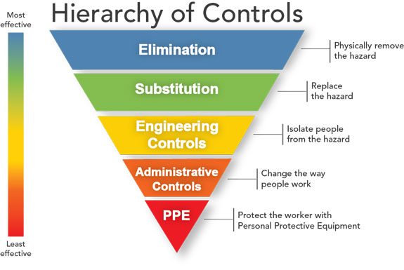

The hierarchy of controls concept was not developed specifically for the COVID-19 epidemic but is applied more generally to the mitigation of health and safety risks in the workplace. The controls that are considered to be most effective are placed at the top of the hierarchy and proceed downwards towards the least effective.

