Where are we now?

The vision of our parish is:

**‘To know Jesus and make him known.’**

Every week in our parish, with your support, we:

* Welcome and work with 100 young people at Youth Fellowship and Youth Club.
* Inspire and excite 80 children about Jesus at Sunday school.
* Serve 200 cups of tea at the Seniors Ministry.
* Visit 25+ people who are ill or lonely.
* Support a family who is grieving the loss of a loved one.
* Run an Alpha Course for 20 people who are seeking to learn more about God and faith.
* Support 50 young families at Toddler group.
* Enjoy worship, host 10 home groups and pray for our faith family.
* Support 3 international charities: Habitat for Humanity, SAMS Ireland and our link church in Romania, as well as many local charities.
* Volunteer in the local food bank and provide support for many families who are struggling financially.

Over the past year we have seen our church family grow, and have enjoyed fellowship and friendship through social activities and special worship times. We thank God for his many blessings, and for helping us share His love in our local community.

Give thanks to the Lord, for He is good; His love endures forever. (1 Chronicles 16:34)

Where do we want to be?

As part of our Generous Giving Programme, we have been discerning God’s heart for our parish, and through a vision-clarifying process we have identified 3 mission and ministry priorities for the next 3 years:

* **Employ a youth worker**

Our youth ministry is run by volunteers but we feel we want to invest further in this invaluable work by identifying and appointing a member of staff to lead this ministry.

* **Begin a lunch club once a month**

There are many people who live in the vicinity of our church who are lonely and feeling vulnerable. This volunteer ministry will provide not just a hot meal once a month but a chance for people to form new friendships, and get out of the house.

* **Identify and train up volunteers for our existing ministries.**

Our parish touches so many lives and we couldn’t have such an impact without the gifts, skills and passion of volunteers. We always need more, and would like to invest in helping people to discover their spiritual gifts and to use them in the right place. Everyone is part of the body of Christ and has something to offer.

There are financial implications to these plans and priorities, and we ask that you would consider

helping to make our plans a reality

through your planned giving.

Financial overview

Our parish relies upon the generous financial support from those who regularly attend church, and around 78% of our income comes through regular planned giving.

Our church family consists of 700 families, however only 420 contribute financially. Of these 420 families, 200 of them contribute less than £/€2 a week.

The average weekly giving per family is 76p/c per day.

Currently only 49% of families who give are part of a tax-efficient giving scheme. This means we are missing out on thousand of pounds/euros from the government each year.

It takes around £150,000 a year to run our parish.

To employ a fulltime youth worker we would need to bring in another £20,000 per year.

If every family which already gives regularly (420), gave an extra £/€2 per week, our giving would rise by £/€43,000 a year!!

If every family in our parish (700) committed to giving regularly, think how it could impact our town and community with God’s love.

We need your help to continue

‘to Know Jesus and

make Him known’!

What next?

**Teaching Series**

**on Generosity:**

Sunday 3rd May at 11am

and

Sunday 10th May at 11am

There will be more information and an opportunity to respond at both of these services.

**Celebration Sunday**

Sunday 7th June at 11am

We would encourage you to **REFLECT**, to **CONSIDER**, and to **PRAY** but most importantly to play your part in the future mission and ministry of our parish and to **ACT**.

*For further details or information about the Generous Giving Programme please see*

*Mr John Brown, our Giving Co-ordinator*

How can I play my part?

**Give a little more:**

To reach our financial goals, our average giving needs to rise from 60p/c a day to £/€1.00 a day – that’s only an extra 40p/c a day or £/€2.80 a week (the cost of a cappuccino from Costa!). If you have never given regularly to the Church we’d love you to consider starting to give something.

**Maximise your giving:**

If you are a tax payer, have you registered with Gift Aid (NI) or signed an Enduring Certificate (ROI)? You can significantly increase your giving without any extra cost to yourself. Relevant forms available from the Treasurer or Giving Co-ordinator.

Do you give by freewill offering envelope? Would you consider signing up for Standing order or Direct Debit? This way you don’t need to worry about having the right cash or bringing your envelope every week and the church will still benefit from a guaranteed payment each month.

**Give of Yourself**

Your time, your talents, your gifts and your prayers are invaluable to our parish. Without these we would be unable to make a difference to the lives of so many people. Please consider getting involved or volunteering in our ministries, and please continue to pray that God will direct and lead us.



Anytown Parish Church

Anytown

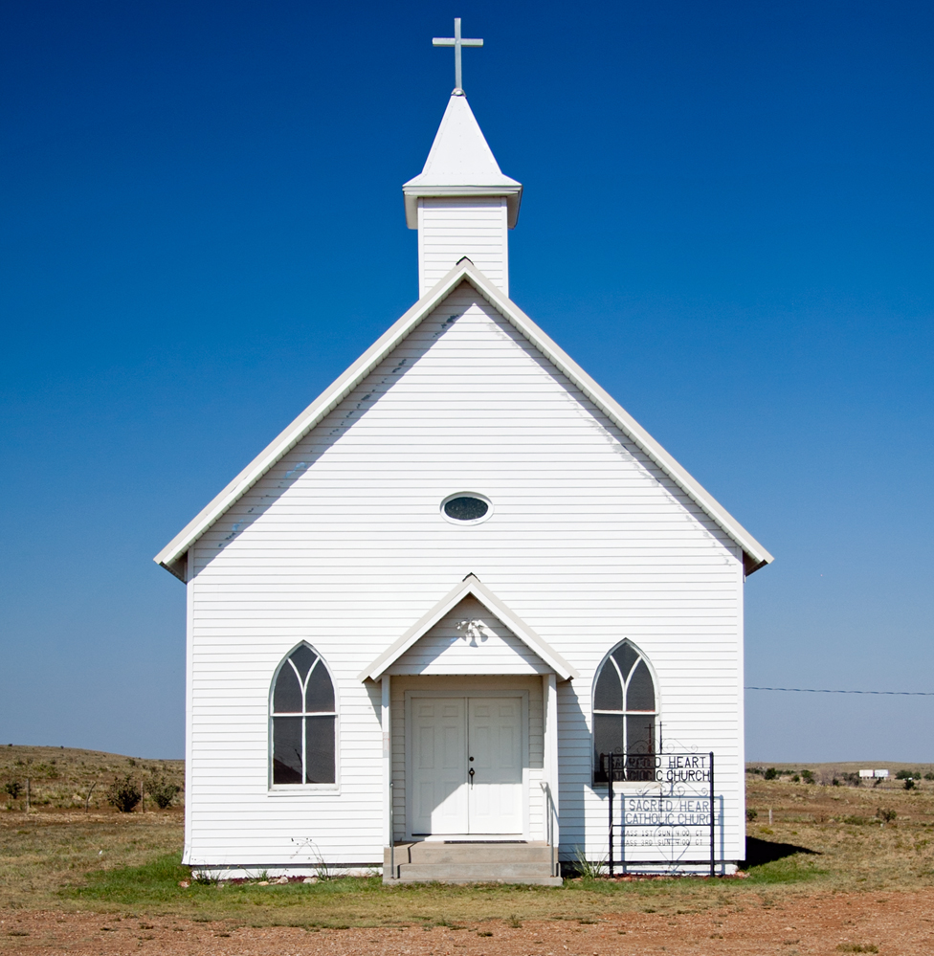

**Generous Giving Programme**