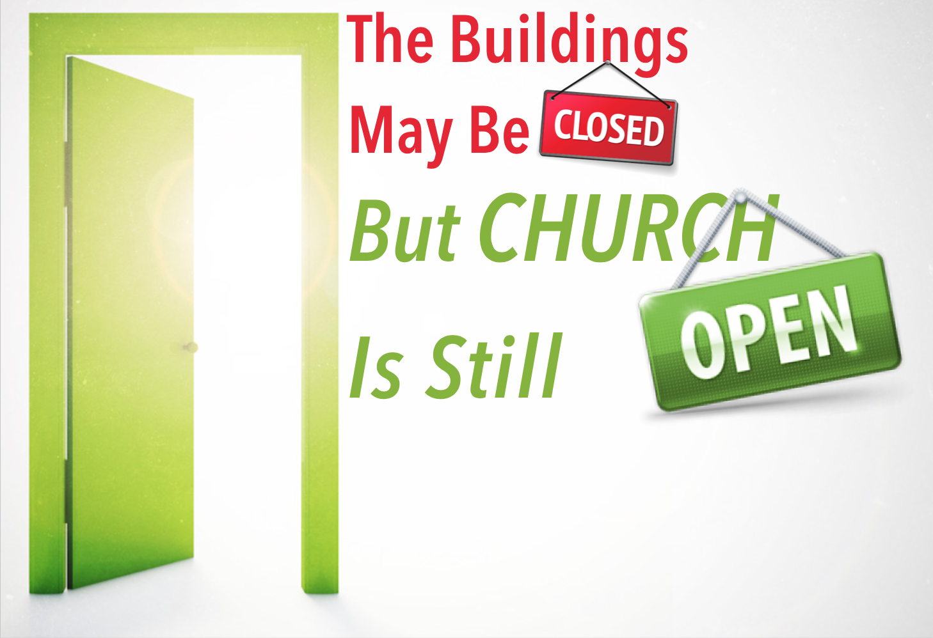

*Insert your*

*church Logo*

*here*

Our online church ***for all*** is at www.facebook.com/your parish

For assistance phone….