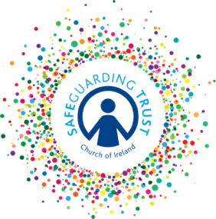
Sample Membership registration form

(Insert Name of Group)

This group meets on (insert day, time and venue of activities) …………………………………

Contact Details

Name of child: _______________________________________________________

Address of child: _______________________________________________________

Age: ________________ Date of Birth: ___________________________

Mother’s Name: ___________________ Father’s Name: _____________________

Address (if different): __________________________________________________

Contact Numbers: Mother - ___________________ Father - ___________________

Emergency Contact Number: ___________________________________

I give permission for (insert child’s name) _______________ to become a member of (insert name of group) _______________________ meeting on the day and times specified above and to participate in all the activities of the group. It is my understanding that my specific consent will be sought for any additional activity outside of the above days and times and venues.

Signed: ______________________________ Date: ______________________

Medical Details

Please indicate if your child:
- Has any allergies - __________________________________________________

- Is taking any medication - ____________________________________________

- Has any special needs - _____________________________________________

I give permission for basic first aid to be administered to my son/daughter. YES/NO

In the case of an emergency, clergy, staff and volunteers will do everything reasonable to contact the parent/guardians named above. In circumstances where medical treatment is required immediately and where it is not possible to contact those named on this form, I authorise the leader in charge of the group to refer my son/daughter to a medical practitioner or emergency services on my/our behalf and to sign on my behalf any written consent required in the event of a life-threatening injury/condition.

Signed: ______________________________ Date: ______________________

Consent must be provided by the person with parental responsibility.

In line with Data Protection regulations, we are committed to protecting the personal information given on this form. By providing the information requested, you are giving us permission (consent) to use this information for Safeguarding, legal or regulatory purposes and we will use it for no other purpose without further consent unless mandated or required to do so under the Data Protection Act 2018 or equivalent legislation. If you have any questions about how we process your personal data, please contact a member of the Panel

