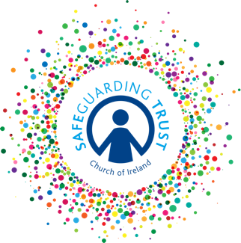
Checklist for select vestries

A basic responsibility is to make sure that children are safe.

This checklist should be completed by the select vestry once a year:

 |  | YES | NO
A.  B.  C.  D.  E.  F  G  H | Is first-aid available during all activities?  Is there an up-to-date first-aid kit available both on the premises and for activities away from the premises?  Do clergy, staff and volunteers know who the First Aider is and where they can be contacted?  Are all accidents and incidents recorded?  How?.......................................................................  Do regular fire drills take place?  Are evacuation notices displayed informing people what to do in case of emergency?  Are fire appliances suitable and serviced regularly?  Has the local fire prevention officer visited the premises?  Is there a Health & Safety Statement in place that covers all parish premises?  Has an Annual Safety Audit been undertaken?  Has an Annual Health & Safety Assessment of activities been undertaken?  Do precautions exist regarding access to premises by strangers whilst children’s activities are taking place?  Has an intercom or doorbell been fitted to parish premises  Has the Select Vestry ensured that the Risk Assessment has been completed?  Is the Child Safeguarding Statement displayed on all parish premises?  Have the panel completed their care of records checklist in past twelve months?  Have the panel, clergy, staff and volunteers completed their checklist in the past twelve months?  Has every external organisation that involves children:  (a) signed the common protocol agreement this year?  (b) provided the parish with a copy of their insurance and child protection policy?  Is this checklist completed annually by the select vestry?

