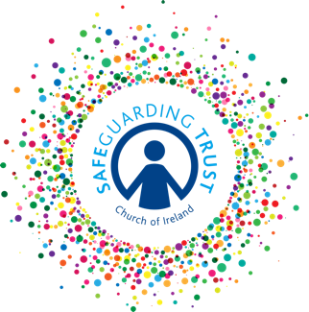
Sample Interview Questions

Beware of ‘closed’ questions which make it possible to answer either ‘yes’
or ‘no’. Ask questions like “What do you think about? /What are your views on…?

Put the candidate at ease - ask first about his/her interests or hobbies.

Discuss the candidate’s career objectives and why he/she applied for this particular post.

Ensure the questions relate directly to the needs of the job.

If any offences were declared by the candidate, the interview should provide an opportunity for an open and measured discussion.

Ideas for questions to ask
You will probably need to choose only one question from each category. The question you choose will depend on the requirements of the job.

1. Relating to experience, qualifications, training
What have been your roles and responsibilities in working with children?
Why are you volunteering for this role?
What skills/qualities would you bring to the role?
What is your understanding of the importance of child protection for staff and volunteers?

2. Relating to children’s learning and development
How would you plan to provide an appropriate programme?
How do you think the group can meet the needs of the children?
What type of activities do you think the group should offer the children?

3. Relating to attitudes
How would you settle new children into the group?
What are your views on establishing and maintaining rules and codes of behaviour in the group?
What would you do if you found a child being bullied and treated unfairly by other children?
How would you deal with a disruptive child?
What are your views on disciplining children?

4. Relating to working with parents
How do you see the role of the parent in the group?
How do you think parents can help you in working with children?
How would you encourage parents to become involved in the group?

5. Relating to working in a team
What do you see as your role in the team?
What skills and qualities can you bring to the team?
How do you feel about working as part of a team?
What is your previous experience of working in a team?
How do you feel about working in a Christian environment?

6. Relating to ongoing personal development
How do you intend to keep up to date with any technical information needed for the job?
What are your feelings about undertaking training?
Is there any area in which you would like further training/development?
What difficulties have you had in attending training in the past?
What training would you need to undertake this role?

