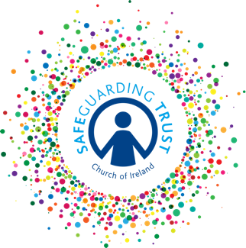

Checklist for Panels and Staff and Volunteers – Safety of Activities

This checklist should be used annual at a meeting of all staff and volunteers/leaders in charge of groups and panel members.

 |  | YES | NO
A | Is a register kept of all those in attendance at children’s organisations?  Has a registration form been completed for each child who attends?  Is an activity consent form used for outings and residential activities?  Is parental consent sought for the taking and use of photographs?
B | How many children are on the register in each group? ________  How many clergy staff/volunteers are in each group? _____________  Are supervision levels appropriate for age of children, activities being undertaken etc?
C | Has each group held a fire drill in the last twelve months?
D | Do clergy/staff/volunteers talk to children about Safeguarding Trust?  Do the clergy/staff/volunteers provide children information leaflets to children (over 10 years)?  Do the clergy/staff/volunteers draw children’s attention to the children’s information poster?
E | Does each group have a Code of Behaviour in place for the members?  Have the children been involved in drawing up this Code of Behaviour?  Have the children been involved in agreeing the sanctions for breaches of the Code of Behaviour?  Have parents been informed of each group’s Code of Behaviour and sanctions?
F | Have any issues arisen in any group in relation to content of activities?  Has each group adequate resources for their activities for the next twelve months?
G | Does any group plan to hold an outing/trip away during the next twelve months?  What planning has been undertaken for this event?
H | Has any group taken photographs of children?  Has parental permission been sought to take and use photos?  How are photographs that have been taken, stored?
I | Does any group use social/digital media to contact children?  Has parental permission been sought?  If there is a social networking site, how it is monitored?
J | Are there any other issues which volunteers/staff have had to deal with which they need help and support with?

