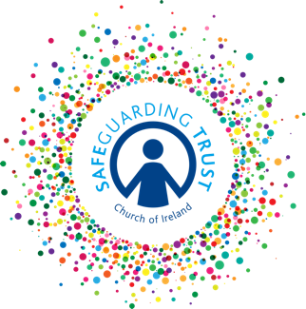
Diocesan Safeguarding Trust Training Strategy Template

Aim of Strategy

To ensure that all bishops, clergy, staff, volunteers, Junior helpers and panel members within the Diocese of (insert name of diocese) are familiar with the Safeguarding Trust and ancillary policies and how to implement them in their children’s ministry work at parish and diocesan level.

Training Strategy

The Diocesan Support team on behalf of the Bishop of the Diocese and Diocesan Council shall be responsible for the provision of Safeguarding Trust training within the Diocese of (insert name of diocese). The Diocesan Council shall ensure that the necessary resources are provided to carry out this Diocesan Safeguarding Trust training strategy.

Training will be provided on a number of levels:

- New Clergy, Staff and Volunteers

The Diocesan Support Team shall ensure that regular Safeguarding Trust trainings for new clergy, staff and volunteers are provided at a local level so that all new clergy, staff and volunteers can attend training within 12 months of their appointment.
The Safeguarding Trust training session aims to provide clergy, staff and volunteers with a greater understanding of Safeguarding Trust and to help them to know how to fulfil their responsibilities in their children’s ministry work.

- Panel training

The Diocesan Support Team shall ensure that regular Safeguarding Trust trainings for Panel Members are provided at a local level so that all new panel members can attend training within 12 months of their appointment.
The Safeguarding Trust training session aims to provide panel members with a greater understanding of Safeguarding Trust and to equip them to fulfil their role and responsibilities as panel members.

- Junior Helper training

The Diocesan Support Team shall ensure that Safeguarding Trust trainings for Junior Helpers are provided at a local level to meet the needs of parishes/diocese.
The Safeguarding Trust training session aims to introduce Junior Helpers to Safeguarding Trust and to provide them with guidance on how to keep themselves safe as they help with the children’s ministry work in their parish/diocese.

- Refresher training

The Diocese of (insert name of diocese) shall require all bishops, clergy, staff and volunteers to refresh their Child Safeguarding Trust Training every (insert number of years) so that they can be kept up to date with all developments in relation to child protection and Safeguarding Trust.
The Diocese of (insert name of diocese) shall require all panel members to refresh their Child Safeguarding Trust Training every (insert number of years) so that they can be kept up to date with all developments in relation to child protection and Safeguarding Trust.
The Diocesan Support Team shall ensure that regular refresher trainings for staff, volunteers and panel members are provided at a local level so that all staff, volunteers and panel members can ensure that their training is kept up to date.

Training Registers
The Diocesan Support Team shall maintain a database of all those who attend training and provide information to parishes on the clergy, staff and volunteers and panel members from that parish who have attended training.

Each Parish Panel shall maintain a register of training information which shall include:
- Details of clergy, staff, volunteers and panel members who attended trainings
- Details of level of training completed by each clergy/staff member, volunteer and panel member
- Details of when clergy, staff, volunteers and panel members should next attend training
- Details of clergy, staff and volunteers who have completed the Declaration of Acceptance

Training Needs Analysis
The Diocesan Support Team shall utilise the information provided on the annual safeguarding return forms to identify the number of new clergy, staff and volunteers who require training and the number of clergy, staff and volunteers and panel members who require refresher training and organise training events to meet the need.

