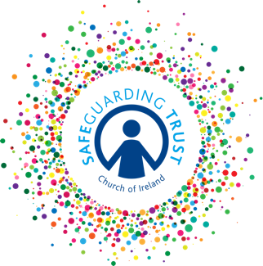
Consent form for social/digital media

(Insert name of group)

Social/Digital Media Consent Form

The staff and volunteers of the above group wish to use social/digital media to contact your son/daughter (if 13 or over) to inform him/her about the ongoing activities and special events of the group.

Consent

Name of Child: _____________________

I give permission for (insert name of group) to contact my son/daughter directly via the following methods:

Please tick the boxes below to give permission for the particular item.

Text messages

E-mails

(insert social networking site)

Contact Details (of child) – fill in if applicable

Mobile Number: _______________ E-mail: ____________________

Signed: ______________________

Date: _______________________

(This consent may be incorporated into the Membership Registration Form – insert section reference)

