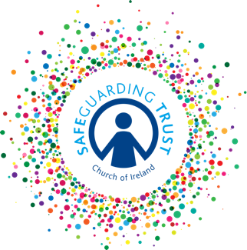
Checklist for panels – care of records

This checklist should form the basis of one meeting of the panel each year.

 |  | YES | NO
A.  B.  C.  D.  E. | Is there is a register of all clergy, staff and volunteers working with children in the parish?  Have all clergy, staff and volunteers at appointment been subject to an AccessNI vetting check?  Have all clergy, staff and volunteers received a copy of the latest edition of Safeguarding Trust?  Have all clergy, staff and volunteers signed the appropriate form acknowledging receipt of Safeguarding Trust documents and declaring that they will uphold the same?  Are all personnel records systematically filed together including the surname and forenames of the applicant, together with previous names?  Records will include:  - application form  - AccessNI check and note on whether the panel deemed that the person was suitable for appointment and forms of identification  - references  - declaration of acceptance  - any notes made by the parish panel during interviews.  - Annual review/appraisal forms.  The date of commencement of responsibility must be shown.
F.  G.  H. | Are these records kept in a secure filing system to which only the parish panel has access?  Is a register of clergy, staff and volunteers maintained showing date of first appointment and subsequent appointments? The date of completion of service must be recorded in the register and on the personnel file.  Are the personnel files of individuals who have completed service retained indefinitely?
I | Is there a register of all trainings attended by clergy, staff, volunteers and panel members?
J | Have the panel completed or ensured that leaders in charge of groups have completed the Annual Review with volunteers / Annual Appraisal with Staff?  Have any training needs been identified?  How will these needs be met? …………………………………….  Have any training opportunities been provided to staff/volunteers?
K | Have the panel requested and received the previous year’s membership forms, parental consent forms and attendance records from each group operating under Safeguarding Trust in the parish?
L | Have the panel reviewed any completed accident/incident report forms and reported to the Select Vestry as necessary?
M | Have the panel ensured that all the following notices are up to date and displayed on parish premises:  - Panel notice  - Children’s information poster  - Child Safeguarding Statement

