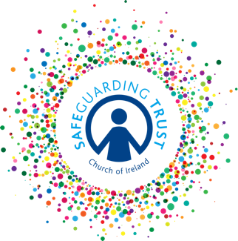

Activity Consent Form

Please complete this form and return it to (insert name of group) __________________

A signed consent form is a condition of participation in this activity for those under the age of 18.

Personal Details

Name of Child: ___________________________________________________________

Age: ________________________ Date of Birth: ________________________

Parent’s emergency contact number: Mother ____________________________

Father _____________________________

I am willing for (insert child’s name) ________________ to participate in (insert name of activity) and confirm that he/she is willing to participate as fully as possible.

Furthermore, I permit (insert child’s name) _________________ to travel on transport that has been designated as official for the purpose of this event.

Signed: _______________________ Date: ____________________

Medical Details

Please indicate if your child:
- Has any allergies - __________________________________________________

- Is taking any medication - ____________________________________________

- Has any special needs - _____________________________________________

I give permission for basic first aid to be administered to my son/daughter. YES/NO

In the case of an emergency, staff and volunteers will do everything reasonable to contact the parent/guardians named above. In circumstances where medical treatment is required immediately and where it is not possible to contact those named on this form, I authorise the leader in charge of the group to refer my son/daughter to a medical practitioner or emergency services on my/our behalf and to sign on my behalf any written consent required in the event of a life-threatening injury/condition.

Signed: ____________________________ Date: ______________________

Consent must be provided by the person with parental responsibility.

