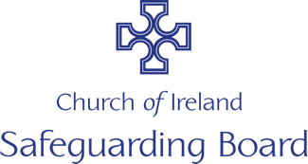
Internal Report Form
(To be used by either a clergy / staff member, volunteer)

You may not be able to complete all of the fields in this form and not all sections will be relevant to a particular concern.

NB A clergy / staff member or volunteer should, in the first instance, report to a Diocesan Adult Safeguarding panel member who will report to a statutory agency.

Name of person

Age

Address and phone number

What is the nature of the concern?

If a person has made a disclosure of abuse, state the name of the person he/she spoke to with the date, time and place

If a person has made a disclosure of abuse, record as precisely as possible what the person actually said

If an adult has expressed concern in relation to the safety of a adult at risk, record if he/she is expressing his/her own worries or passing on those from another adult. Record the concerns and ask him/her to confirm that the details as written are correct.

Have possible signs or indicators of harm been identified? YES/NO

If yes, please outline below

Record the name(s) of the person(s) alleged to have harmed the adult at risk:

Signed by staff member/volunteer

Date
FOR DIOCESAN ADULT SAFEGUARDING PANEL USE ONLY
Report received by

Signed Date

